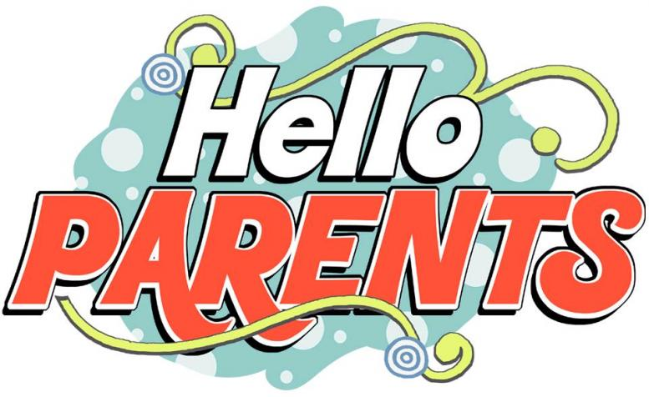

[This Photo](http://englishsafalleida.blogspot.com/2015/09/if-your-child-is-in-5th-or-6th-e.html) by Unknown Author is licensed under [CC BY-NC](https://creativecommons.org/licenses/by-nc/3.0/)

**Parents, please click on the link below to give EPISD your input on reopening schools for 2020-2021. Every survey response matters. Please complete by next Wednesday. Thank you!**

<https://www.surveygizmo.com/s3/5600875/2020-2021-District-Reopening-Parent-Survey>